Steps to Download Sound:

1. Open the code you want to use
2. Go to “Sketch” at the top of your screen
   1. Go to “Import Libraries”
      1. Go to “Manage Libraries”
3. Search “Sound”
4. Install the file created by “The Processing Foundation”

Your audio file:

1. Find a short audio sample you want to use. You can do this by recording something with garage band or voice memo. However, you want your clip to be less than a second long or your sound will risk severe distortion.
2. Make sure your clip utilizes “.mp3” as the file type
3. Go to the folder you have your work saved in (Should be in “Processing Demos” or whatever you named this folder in your Intro CS folder).
   1. You can do this by either going to your finder or using your terminal
4. Find the folder with the name of the code you are working with. Inside of that folder, there is a “.pde” file. Enter this folder.
5. Create a *new* folder inside of here entitled “data” all lowercase.
6. Move your audio file into this “data” folder.

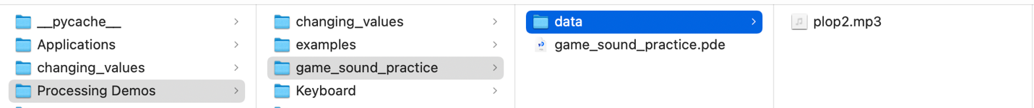

Telling your code that you have sound files:

To access the Sound files in your Code, on line 1 write:

**import processing.sound.*;**

Using audio files as a variable in your code:

To implement sound as a variable in your code, you initialize as such:

**SoundFile VARIABLE_NAME;**

SoundFile is written like any data type we are familiar with. For example, “int x” or “float coconut.”

Telling your variable what audio you are using:

In void setup(), you initialize your variable by following this line of code:

**VARIABLE_NAME = new SoundFile(this, "AUDIO_NAME.mp3");**

* “VARIABLE_NAME” is what your variable is
* “SoundFile” is your data type
* “this” refers to its sketch folder location (you’re going to always want to use “this”)
* ““AUDIO_NAME.mp3”” refers to the name of the file in your data folder and you are going to want to include the quotation marks here.

Getting your code to play the sound:

Now, you’re going to want to move to your void draw().

To get your sound to play you want to use VARIABLE_NAME.loop() or VARIABLE_NAME**.**play() depending on how you want it to run.

For more methods you can use, here is the reference page:

[*https://processing.org/reference/libraries/sound/SoundFile.html*](https://processing.org/reference/libraries/sound/SoundFile.html)